CSS Transitions

Table of Contents

What are CSS Transitions? 1

The Hover Event 3

To set up the code 3

Speed Curve of Transitions 4

Transform 6

Translate 8

Using Autoprefixer 9

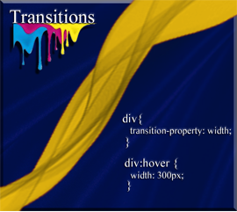

# What are CSS Transitions?

Transitions are an easy type of animation that you can do with elements on your web pages. They are fairly simple to understand, so don’t get scared off right from the start of this thing.

To create a transition effect, you will need to specify two things

1. The property that you want to mess with
2. And the time it takes for the property to be messed with

Well, I suppose before we can even begin trying to transition anything, we are going to need something to transition. That is easy, we got a div and we know how to make it a box.

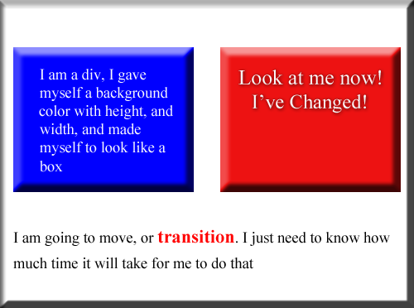

Oh, yeah just tell me what I am, and how much time I got.

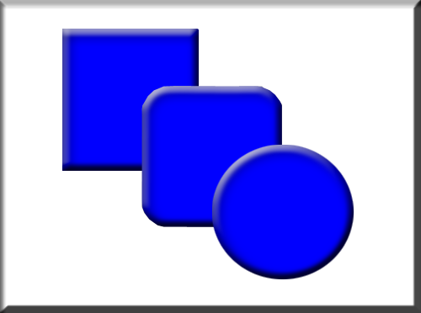

# The Hover Event

Now what will we use to transition us? The hover event is something most of us have already used, when we transitioned the color of a button or a hyperlink to look different whenever a user hovered their mouse over it.

So, a hover event is also the perfect mechanism to use, when we want to enable simple animation.

# To set up the code

If you just set your code to target div, you will find that all of your divs will be effected, and that is probably not what you want. So, best to create a div in your html, and then give it a class name, where we are only targeting that div alone.

**The Html**

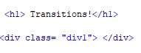

Notice that in order to create a simple animation like this, the only code which might be unfamiliar is just one line. So, if you learn to use the property **transition**, on top of what you already know, then you are animating.

**The CSS**

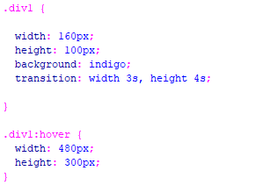

Now if you run it, and hover over your rectangle, you will find that your height of the shape is taking 4 seconds to reach it full size, when the width is only taking 3 seconds. Because that is what was specified in our ***transition*** code.

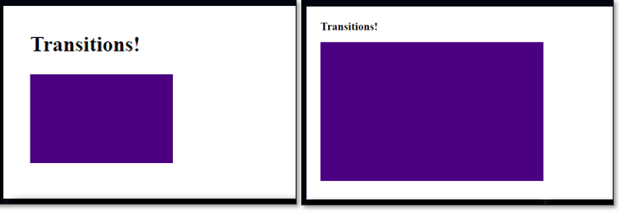

# Speed Curve of Transitions

The speed curve, is something that will allow you to determine how fast the element you are working on, starts to do what you want it to do, and then also how fast, at the end that you want the element to stop doing what you want it to do.

You can set your speed curve at different settings, something like a fan, except that you are working with speeds at the beginning and end of the movement of your object.

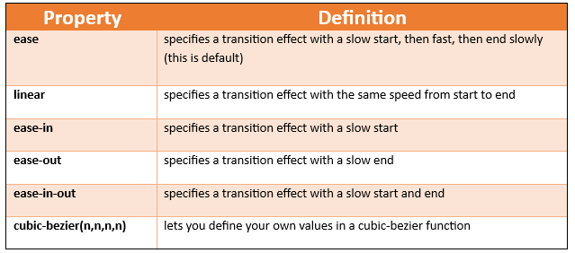

This is how you would write this timing function in your code

**HTML**

<h1> Transitions!</h1>

<p>Hover over the div elements below, to see the different speed curves:</p>

<div class="div1">linear</div><br>

<div class="div2">ease</div><br>

<div class="div3">ease-in</div><br>

<div class="div4">ease-out</div><br>

<div class="div5">ease-in-out</div><br>

**CSS**

.div1,.div2,.div3,.div4,.div5 {

width: 250px;

height: 130px;

background: green;

transition: width 3s;

font-family: "Times New Roman", Times, serif;

font-size: 36px;

color: #D3CBBC;

text-align: center;

vertical-align: middle;

}

.div1 {transition-timing-function: linear;}

.div2 {transition-timing-function: ease;}

.div3 {transition-timing-function: ease-in;}

.div4 {transition-timing-function: ease-out;}

.div5 {transition-timing-function: ease-in-out;}

.div1:hover {

width: 400px;

}

.div2:hover {

width: 400px;

}

.div3:hover {

width: 400px;

}

.div4:hover {

width: 400px;

}

.div5:hover {

width: 400px;

}

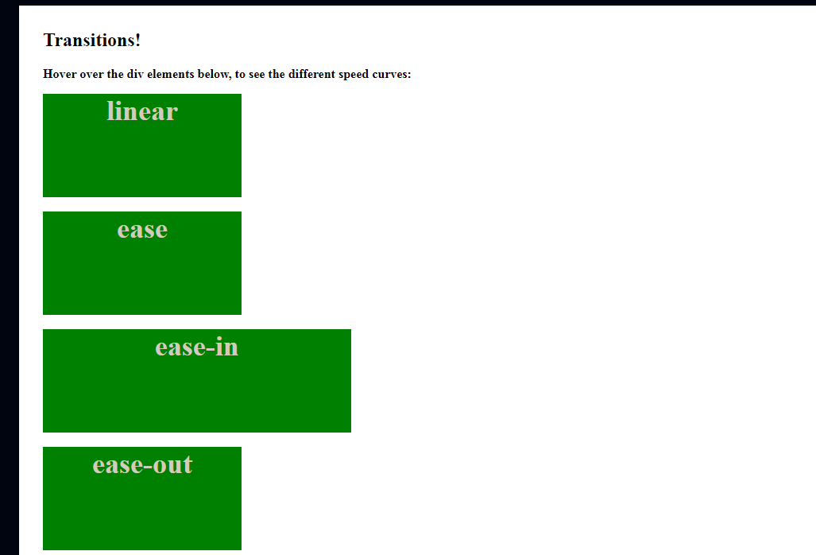

**Transition Delay**

You can set a transition delay. Now all this will do is to set a time for the animation to wait, before it starts doing what it wants to do. Of course, if you are setting this delay in the hover event, your user will expect it to be doing something as soon as they start to hover over it, if it is giving the user a delay, they will think it is broken. However, you may want to add it to the load property for your page. Anyways, here is this delay thing. Use it in your animation if you want.



**Transition duration**

You could also add a duration, but setting how many seconds you want the transition to go will pretty much do the same thing.



# Transform

This is just a very simple look into animating some of your properties. If you want to get into some of your more intense properties you will need to use Transform. Using transform will allow you to maneuver things like rotate, move, skew, and scale.

Scale

**HTML**

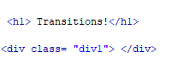

**CSS**

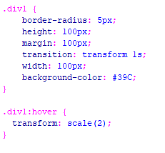

Rotate

**HTML**



**CSS**

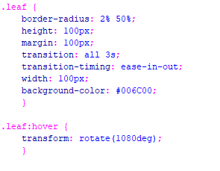

Skew

**HTML**



**CSS**

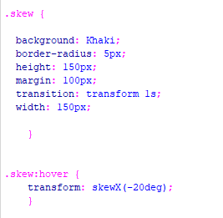

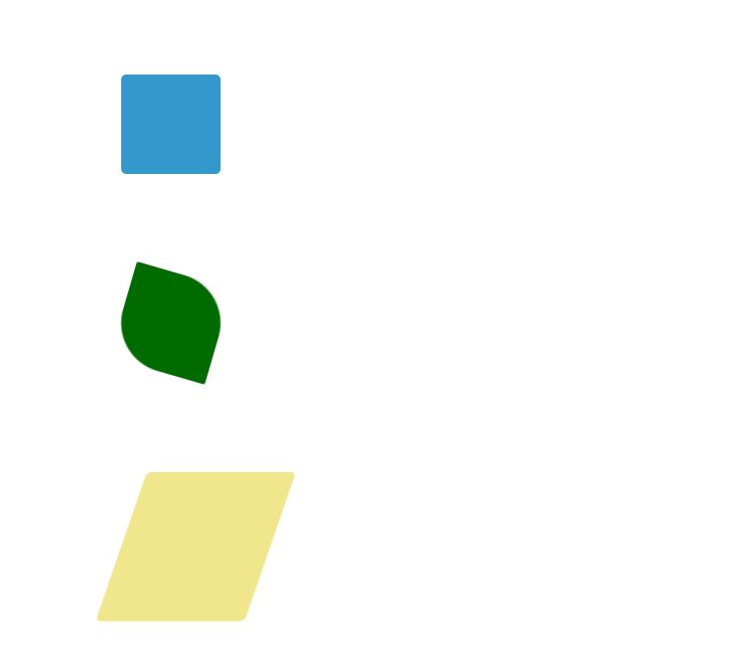

# Translate

Translate is another property that allows simple animations of our object. If you would like to have your element move from one position into another on the page, you would use **Translate**.

**HTML**



**CSS**

You will notice that we are adding a new way of adding a hover, and that is by placing it directly into the .moveIt rule. We will use the & sign a colon and the word hover to get this done.

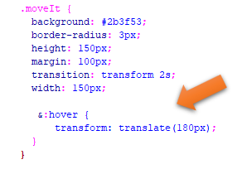

# Using Autoprefixer

You can use the Autoprefixer in Visual Studio, to make sure everything works correctly on all browsers. Remember we had gone over using this add-on in our chapter on working on all browsers, which you can find [here](https://starsindust.github.io/Enlightenment/Articles/2024/1-Flexbox/4-Working-With-All-Browsers/4-Working-With-All-Browsers.html).

You have to remember that if you do use this Autoprefixer, that it will only recognize code from the CSS file, and if you placed your code in the heading of the document, you will have to copy it all into a CSS file, highlight it and then use Autoprefixer by hitting F1 and choosing it from the dropdown.

Autoprefixer:Run

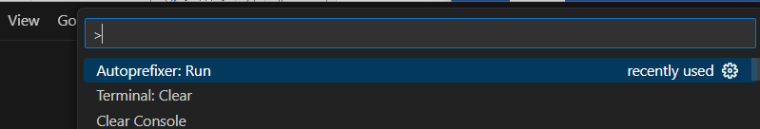

Notice how -webkit, and -ms was added in some places in your code

